Mathematics Foundation

Practical Application

Fish Days

Year 11 Unit 1

Brief Description:

This practical application allows students to demonstrate their understanding, problem solving and reasoning in the context of reading data from a graph to determine best fishing conditions. Students will need to use the mathematical thinking process throughout this assessment.*

Syllabus Dot Points:

1.5.3 read and interpret information from a range of simple data displays for real life contexts, including lists, one and two-way tables, column/bar and line graphs, Venn and arrow/network diagrams

1.5.6 determine whether interpretations from tables and graphs are reasonable for the context

1.5.7 communicate information and conclusions from graphs and tables consistent with the language of the context

Recommended Time:

1 lesson

*Students should be explicitly taught the Mathematical Thinking Process in conjunction with learning of course content, not just in assessment form. Copies of MAWA classroom posters are available at <https://drive.google.com/file/d/1c3GfM1o4cSBrzyWaFFIYlAmPU3-KS-rx/view>

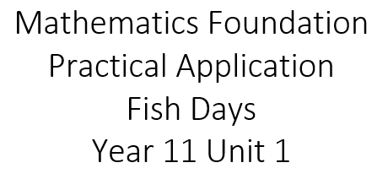

Fish Days

Fish prefer stable and consistent weather patterns, regardless of the conditions – sunny and warm, cold and raining, or windy. The best fishing usually occurs on the third day of a stable weather period as this is when they are most active and their behaviour the most predictable.

Your friend would like to go fishing with you next month in Walpole. In preparation, you have found the following long-term forecast for Walpole.

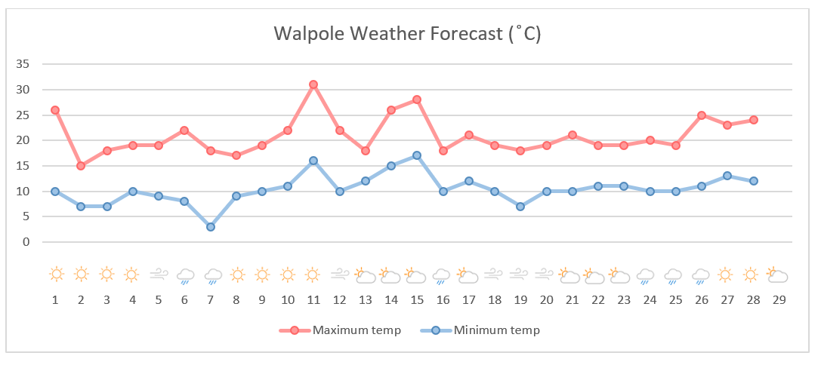

|  |  |
| --- | --- |
|  | Sunny |
|  | Partly cloudy/overcast |
|  | Rain |
|  | Windy |

Your task is to decide which day/s you would recommend your friend to go fishing.

***You must support your answers with mathematical reasoning and evidence.***

Your practical application should include the following:

* Key words/information highlighted
* A brief description of what the task is asking you to do
* Interpretation of information from the graph provided
* A concluding summary of your findings linking back to the original question (2-3 sentences).

**Marking Key**

|  |  |
| --- | --- |
| **Interpret task** | |
| have to find the best day for a friend to go fishing. I am going to use the graph to find the third days that have three of the same weather patterns in a row. | |
| **Specific behaviours** | **Marks** |
| Highlighted key words/information | 1 |
| Brief description of task | 1 |
| Identifies third day of consistent weather | 1 |
| **Total** | **/3** |

|  |  |
| --- | --- |
| **Mathematical Modelling** | |
| I have found that there are 8 possible days that is the third day of the same weather pattern. Day 3, 4, 10, 11, 15, 20, 23, 26. | |
| **Specific behaviours** | **Marks** |
| Identifies at least 1 possible day | 1 |
| Identifies at least 4 possible days | 1 |
| Identifies all possible days | 1 |
| **Total** | **/3** |

|  |  |
| --- | --- |
| **Interpretation & Conclusion** | |
| The best day to fish is the third cay of the same weather. I have 8 possible days to recommend to my friend. They are highlighted on my graph. If I had to choose the best one, I would say Day 23, as it has more consistent conditions and it doesn’t have any real spikes in max/min temperature. | |
| **Specific behaviours** | **Marks** |
| Brief conclusion linking to the original problem | 1 |
| States more than one possible answer | 1 |
| Identifies most preferred day | 1 |
| Supports conclusion with mathematical reasoning | 1 |
| **Total** | **/4** |

**Marking Checklist**

MTP Checklist Student Name: ____________________________________________________

|  |
| --- |
| **Interpret the task and key information**   * has identified key information * can rewrite problem in their own words * has identified any information that is not needed, or is missing * asked for clarification |
| **Choose the mathematics**   * identified all the mathematics required * chose an effective strategy: _____________________________________________________ |
| **Apply existing mathematical knowledge**   * followed through with their plan * showed all working (even when a mistake was made/changed their mind) * appropriate use of units applied * worked independently |
| **Interpret results**   * solutions answer the original problem * has identified what worked and what did not * has checked work by using a different method |
| **Communicate**   * work is organised allowing for partner/teacher to understand * can explain their work when asked * has written a concluding statement linking back to the original problem |
| **COMMENT:** |